Client: RannLab Technologies

Submitted By:

Rama Nayudu 30357452  
Manish Pasham 30354359  
Afreen Seema 30355067  
Money Arora 30358798

ITECH 7415  
Gym Training automation tool

Group 51

Contents

1. Introduction 5

2. Problem Statement 5

3. Aim of the Project 5

3.1 The Product Vision 6

4. Literature Review 6

4.1 Effectiveness of Commercial Fitness 6

4.2 Gym and Fitness Innovation 7

4.3 Field of the invention: 7

1. Background of the invention: 7

4.5 Summary of the Invention: 8

4.6 Detailed description of the invention 9

4.7 Quality of virtual fitness trainers: 12

4.8 Ideal state: 12

4.9 Key Opportunity: 12

4.10 Training routines: 13

5. Methodology 14

5.1 Agile Process 14

6. REQUIREMENT ANALYSIS 15

6.1 IntelliJ Idea 15

6.3 J2EE 15

6.4 MySQL 16

7. Product Discussion 17

7.1 Technical Architecture 17

7.2 Module 17

7.2.1 Administrative Module: 18

7.2.2 User Module 18

7.3 Features 18

7.3.1 Features Description 18

8. Programming Interface of Application 19

8.1 Parameter Consideration in Gym Automation Tool System 19

8.2 Presentation layer: 19

8.3 Service layer: 19

8.4 Database layer / Database: 19

9. Existing System Constitutes 20

9.1 System Architecture 20

9.2 Data processing 20

9.3 Design of View Layer 21

10. End to End Architecture 22

10.1 Explanation 22

11. Roadmap Of Proposed Solution 23

11.1 Advantages: 23

12. The Proposed Model Considers These Properties 25

12.1 Internet Oriented 25

12.2 Things Oriented 25

13. The System Study 25

13.1 The project study basically deals with different operations: 25

13.2 Following are the steps taken during the initial study: 26

13.3 Existing System 26

13.4 Proposed System 26

14. UML Diagrams 27

14.1 Use Case Diagram 27

14.2 Sequence Diagram 28

14.3 Class Diagram 29

14.4 Activity Diagram 30

15. Software Requirements 30

15.1 User Interface: 30

15.2 Application: 30

15.3 Development and Build process: 31

15.4 Testing: 31

15.4.1 White Box Testing 31

15.4.2 Black Box Testing 31

15.4.3 Alpha Testing 32

15.4.4 Beta Testing 32

15.4.5 Unit Testing 32

15.4.6 Integration Testing 32

15.4.7 Validation Testing 32

15.4.8 System testing 32

15.5 Implementation and Software Specification testing 33

16. System Analysis 35

16.1 Introduction To system Analysis 35

16.2 Feasibility Study 36

17. Future Scope And Limitation 36

18. Conclusion 37

19.User Manual 38

19.1 How to Register and Log in the account 39

19.2 How to check Workout on site 40

19.3 How to Get Medical Certificate 41

19.4 How to Upload Everyday Workout 42

19.5 How to Select Exercise Package 43

19.6 How to check Blogs on site 44

19.7 How to Log out from account 45

20. List of exercise 46

20.1 Push-Up 46

20.2 Squats 46

20.3 Single Leg Balance 47

20.4 Skipping 47

20.5 Cycling 48

20.6 Standing Barbell Curl 48

20.7 Hammer Curl 49

20.8 Standing Dumbbell Curl 49

20.8 Chin-up 50

20.9 Concentration Curl 50

21. Screens 52

References 58

# Introduction

We, in general, acknowledge prosperity could be a wealth. We need not waste time with an expensive vehicle, huge space, a master certificate without prosperity. RannLab technologies is software company which wants the project team to design a website for gym member where member can log in their accounts and choose the exercise according to their requirements and use the machines without a gym trainer.

This undertaking is meant to encourage a gymming and wellness to mechanize its activity of keeping record and store them within the variety of an unlimited and simple to use database further encouraging simple access to the individual. In that, we furnish every exercise with its portrayal with picture which is easy for the client to induce the way to do exercise. This Gym robotization instrument need not bother with any rec centre coach for Gym. The client can get to its records and once he gives the information about himself/herself it'll store into the database by making User-Id and secret phrase. Additionally, we are able to store his all day by day see subtleties into the database. The Gym Automation Tool wipes out the greater a part of the impediments of this framework. Increasing quality and adequacy, mechanization, precision, convenient to grasp mediator, information accessibility, correspondence limit, support, cost decrease makes our framework more intelligent than the present framework.

# 2. Problem Statement

As in typical gym centre, the coach is required for the client with the goal that he/she can do exercise appropriately. Our suggested application "Gym training automation System" is for the organization that maintain an activity centre business. Before doing anything we did a superior to normal examination on very hard for gym focus franchisee. We investigated warily about a new concept with an amazing enlisting structure excluding frustration similarly as major capacities with regards to a special reasonably customer depending upon. A mentor isn't required for the gym centre or wellness focus there are subtleties of the way to play out the activity.

# 3. Aim of the Project

The Gym organization need a framework that may house all the important and moment subtleties effectively and legit secure database appropriately to the client. They requires system, which can the capacity of storing the information of Admin of the gym, list of exercises, equipment, location, timings, daily workout. Some of the information will be shared by every one that will occur in Gym implies section and exit.

So, the main objectives for our system is as below,  
The fundamental target of the undertaking is to structure and build up a simple to grasp productive mechanized Gym Automation System.

* An accurate system with none data redundancy.  
  Secured data storage for Authority end.
* Secure the user ends data by providing each user’s own personal credentials.
* A flexible system which might maneuver the customer-staff relationship in an efficient manner.
* To give better graphical UI.
* Computerization are often helpful as means of saving time & money.

## 3.1 The Product Vision

The objective of the Gym computerization instrument is that the database the executives of the considerable number of people. This stores administrator, part and items data. It additionally gives the office of search the exercises subtleties and framework shows the records productively and quickly just on the off chance that you simply are approved client. This framework gives day by day information putting away of the particular client and report age for the administrator with graphical UI (GUI).

# 4. Literature Review

## 4.1 Effectiveness of Commercial Fitness

Wellness is by and huge observed as a late twentieth century marvel, yet perceive that a little of its underlying foundations had just advanced over a century prior. Present day innovative wellness gear has been turned into an intensive and effective industry, and advertising items and their ubiquity, as human-related machines, assume a vital job. A leading edge wellness focus is profoundly proficient in its utilization of reality, both in design even as within the concurrent utilization of wellness innovations. Clients have found out a way to screen their own bodies as indicated by the measures of being 'fit'. The globalization of present-day wellness culture is viewed as a lighting up case of the all the more grasping force toward a worldwide monoculture, and it's an unmistakable and versatile wonder overall . The unification and normalization of wellness (both gear's and practices) are pivotal for the globalization of the wellness business. The authentic improvement of present-day rec center and wellness culture may be portrayed logically to understand the increase of this multi-billion-dollar marvel.

## 4.2 Gym and Fitness Innovation

While wondering the long periods of distribution, a transparent increment in papers on the engaged subjects of intrigue was watched [7]. Until the beginning of the 21st century, there's no progression on creation. From 1978 (lower limit characterized during the investigation) to 2006, just 14 articles were distributed (28%). Over the foremost recent 10 years (from 2007 to 2016), a mean of multiple distributions once a year was confirm, with two tops during 2011 and 2014 with a mean of 5.5 chose articles [8]. Likewise in exercise center and wellness focus all of them need is mentor for the clients who can direct him/her so exercise will simple. Current proposals attest that wellness exercise centers and personal fitness centers are an interesting worldwide business, yet new 'patterns, for instance, diversifying chains, and explicit condition exercise spaces are the new boondocks of item creation focused on definite buy and solidification [9]

## 4.3 Field of the invention:

The invention is identified with on-line PC based work-out program training. Specifically, the innovation offers on-line exercise training for clients with specific accentuation on the most proficient method to utilizing the gym equipment. The invention gives online virtual individual training to a client with the assistance of a decision of virtual mentors, in view of client's needs and aptitude level.

## Background of the invention:

Training is a basic piece to achieve betterment in the program workout. Most people (clients) that have utilized a gym centre know about a portion of the exercise and with the gym equipment as well. In any case, there are times when people need to enrol the expert assistance or trainer to guide themselves with the different exercise programs, the best possible method of utilizing the gym centre and to prescribe great exercise projects to suit their necessities and expertise levels. Gym equipment recordings are accessible to show general standards on the best way to utilize gym tools in a best way. However, these videos gradually give a brief area of workouts and doesn’t provide the complete information regarding the workouts for the equipment which are already available in the gym.

Some portion of the explanation an individual uses a trainer for inspiration and the mentor's information in the field of physical wellness. While past video practice programs give the subtleties of how to utilize gym equipment, it doesn't go far enough to let the user pick the trainer and customize their activity schedule. Customizing their activity routine provides them with the best possible inspiration to adhere to their schedules.

Another area of concern is the absence of accessibility of trainers all the times of the day. Most specialists say that live preparing by expert teachers is the best methodology, however this is regularly illogical, particularly when an individual is travelling or when an individual need to turn out to be during a period based on their personal reasons. More often individuals are carried out with their busy schedule with the different work on their different time, don't have the opportunity to go to a gym centre during gym centre hours when trainers are accessible. Regardless of whether they have the opportunity, they must prepare and plan a meeting with the trainer to guarantee the trainer's accessibility. Besides, when the individual needs to travel surprisingly he/she won't have the option to keep his/her arrangements and should re-plan

The PC based training considers quick, economical access to preparing from any area and whenever. A promptly open customized preparing routine may helpful for user without missing the schedule and helpful to make up the person's activity schedules while out traveling (business or individual). PC based training gives a modified exercise calendar to the person to follow at his/her own pace. The virtual training gives the one-on-one preparing that a user searches for in a gym centre however gives the individual a decision of where and when to get such preparing and is additionally an incredible substitute to having a personal trainer. computer based training for the new user can be effortlessly made accessible to the individual/client through a site without purchasing another video or new programming. Use and appreciation of the preparation substance can be mi checked progressively and outlined or needed.

## 4.5 Summary of the Invention:

* Appropriately, it is an object of the development to give a way to powerfully created training to give every person/client a trainer explicit and trainer specific exercise understanding.
* It is another object of the development to give a powerful decision of picking any trainer and any exercise alternative to follow.
* It is another object of the development to give the decision of exchanging trainers or exercises relying upon the enthusiasm of the client.
* It is another object of the creation to empower the trainers to impart their own skill and information to the clients simulating the live involvement with the gym centre.
* It is another object of the development to give an on-request, compact answer for the activity schedules.
* It is another object of the development to give financially cost-effective alternatives as and when the new hardware comes to the market.
* The current development offers clear description to a client of how to utilize typical gym hardware equipment’s without putting resources into a trainer or physically be at the gym centre. The Virtual Trainer application is introduced on any standard PC and got to by a hand-held gadget or on a PC associated with a system and got to from any standard PC or hand-held gadget associated with a similar system. With the various of different palm gadgets and simple access to the system the application is effectively available from anyplace utilizing a PC or palm gadget with no extra equipment prerequisites. The Virtual Trainer application gives the client a choice to pick a trainer to work out with and an exercise result to follow, all in the comfort of the handheld gadget or a PC. The application likewise allows the client with the capacity to choose from a dropdown or from a structure show and gives a rundown of activity results to be accomplished from different gym equipment. The application could be used to all the time even in a gym centre during any standard exercise as a good substitute to a trainer. The selection of trainers and exercise results give the client the adaptability and assortment for a fascinating and propelling exercise.

4.6 Detailed description of the invention**:**

The current innovation is an intelligent training application involving a training database wherein the preparation database gives data identified with exercise preparing. The data in the training database involves data on most coaches and most activity schedules to work different zones of enthusiasm for the human body to get an ideal outcome a client need. The territories of intrigue allude to the different muscle gatherings of the human body that can be worked out. The data in the training database likewise includes data on a majority of exercise centre hardware and realistic exhibit of how to utilize every one of the gym centre with subtleties on which muscle bunches are being worked and what gym to use to get the ideal outcome. The data on coaches incorporates their memoir, their certifications and their territory of specialization as identified with the preparation.

In general, the current creation is an intuitive preparing technique and framework to help clients exercise truly to accomplish the ideal body results. It gives the inspiration and support to clients by acquainting them with appropriate exercise schedules, proposing the right exercise schedules to play out, the succession of these activity schedules to follow and give assortment by permitting them to pick the schedules or the training powerfully. A favoured encapsulation is clarified in more prominent detail in the accompanying sections yet is illustrative and isn't expected to be restricting the innovation in any capacity.

A client and individual are utilized conversely in this application. A client is an individual utilizing the application or doing the exercise as referenced in this application. The trainer as utilized in the accompanying passages is a virtual trainer who exhibits the activity schedules to follow to accomplish an outcome to a client.

In one of the encapsulations, the technique utilizes an independent PC, for example, a PC, work area, a workstation or something like that, to introduce the database. The client at that point gets to the database to pick the trainer and exercise routine to follow and refreshes the database with the important data in the following log. The database from the independent PC can likewise be down stacked to a Personal Digital Assistant or other hand-held gadget with an implicit screen/screen or having the capacity of associating with a video screen or video screen. In another encapsulation of the development, the application is on a capacity gadget, for example, a reduced circle, a Flash memory module or something like that, that can be hefted around. The client would then be able to module the capacity gadget, for example, the conservative circle (CD) into the proper space, for example, a CD player on the PC/registering gadget or the blaze memory module into the fitting opening of the PC or figuring gadget, to get to the database. It permits the clients to get to the database utilizing the info/yield gadget of an ordinary PC, for example, a console and a video screen/contact screen or from a Cell Phone, Personal Digital Assistant (PDA) or other hand-held gadgets with adequate memory utilizing the keypads/consoles/number cushion and video screens/show screens. The updates from clients are performed non-concurrently comparative with the clients' request and info so the data on the training database is consistently current.

In another exemplification of the innovation, the technique utilizes a web server, comprising of a database and a web application. Various clients associate with the site on the web server a through the Internet to get to the database. The information is put away in the database utilizing the database motor.

The framework interfaces most clients to a Web server through the Internet. The web server is associated with the Internet through Wide Area Network (WAN) by any of the accompanying methods: T1 line, DSL (Digital Subscriber Line), Cable Modem and telephone modems. The Web server empowers facilitating the site and running the web application. The clients get to the database through any gadget equipped for getting to the database over the Internet. The gadget might be a Desktop Computer Workstation, Interactive Television, Laptop PC, Cell Phone, Personal Digital Assistant, or some other hand-held gadgets which permits a client to access and update data on the database. The Web server a possibly a various server PC designed to show up as a solitary asset. A database made through the database motor holds information on the coaches, practice schedules and exercise results to be accomplished. A Web application is a piece of the Web server. The Web server could be any industrially accessible web server, for example, Microsoft's Internet Information Services (IIS) or Apache. The web application encourages the UI to the preparation database utilizing an Internet or Web program. The database gets inquiry and update demands on progress produced using web application, started by clients. The updates are performed no concurrently comparative with the clients' request and info so the data on the database is consistently current. The entrance to the Internet could be by a remote association or by a wired association. The remote association could utilize the blue-tooth innovation or whatever other innovation that permits graphical exchange of information or access the database on the PC by processing gadgets.

"Meet the Trainers" alternative is a drop-down menu where the client is permitted to pick from a gathering of training. At the point when the client picks a training, he/she is given a video picture of the picked mentor alongside the memoir of the trainer, trainer's accreditations and region of specialization identified with the preparation. The client is permitted to switch between different mentors whenever during the activity meeting by picking the "Meet the Trainers" button showed on various screens. The client at that point continues to pick the activity result they need to escape the exercise by heading off to the "Pick your Workout" choice.

The "Track your progress" alternative provides the client with a Tracking log where the client is given an intelligent screen to enter information identified with the exercise and a choice to view and print a log of the advancement made during a timeframe. The information is entered utilizing any information gadget associated with the PC or figuring gadget such as, a console, key cushion, a number cushion or something like that.

## 4.7 Quality of virtual fitness trainers:

Fitness training is increasingly viable and yield more prominent improvement as illustrated by Davis (1998) gave the client knows whether which activities to be performed and what level of trouble to apply with. It backs to supporting long haul inspiration, as the client knows about their preparation progress. Through versatile wellness applications which clients can emulate the correct method of doing each activity, improve and the outcomes successfully noticeable after assigned modules are finished

As per Dale (2009), identifying right exercise execution, virtual wellness trainer on versatile takes out the requirement for changeless management by a physical person. It isn't just backings relaxation time working out yet absorbing an important supplement for restoration reason. Versatile wellness application bolsters self-sufficient preparing through thorough exercise depictions subtleties data on selected training.

## 4.8 Ideal state:

An individual trainer is an electronic fitness trainer that makes altered preparing plans dependent on study of activity, fit to individual’s body, objectives, and way of life factors, including, length, exercise spot, term and focused on equipment.

At the point when user enter their activity, an individual trainer utilizes this information to investigate their advance and refine individual exercise designs so normal users can streamline their wellness what's more, adjust to plan changes.

West (2012) articulated portable and remote innovations use to help the

progression of wellbeing objectives has completely changed the substance of wellbeing administration over the globe borderless. An incredible mix of elements is driving this change. Ascend in joining of portable wellbeing into existing wellbeing administrations makes preparing schedules and even eating regimen go live whenever and all over. Track progress segment has adding machines for weight record (BMI), hydration, pulse, calories counter for net calories got from preparing and food consumption also as space to transfer photographs and track your weight, BMI, midsection size and other estimations.

## 4.9 Key Opportunity:

Goodman (n.d.) express that cell phone can helps the user to be fit by causing them to get data effectively like sound plans. Other than that, it can assist user with learning new exercises, train for a forthcoming objective, and screen your advancement. Paul (2013) likewise bolster the possibility of cell phone assist you with remaining fit by utilizing the Samsung S4 recently contraptions which is known as the S wellbeing device comprise of a S Band, Body Scale and HRM which can improve one's wellness. The telephone capacity can assist the user with telling the perfect load to focus on and what number of calories every day a user should take to accomplish the body physical make-up they want for. As indicated by an online source, healthreviser.com, cell phone can design your exercise plan for you to improve your wellness level.

## 4.10 Training routines:

Other than reminding client to work out, this application will likewise give all around arranged and compelling preparing schedules for the client to follow. This is the centre capacity in supporting the client to arrive at their longing fitness level. The preparation schedules a trade-off of preparing exercise that centres around execution, quality and cardio workout. For performance exercise is an exercise to improve the nimbleness of the client muscle. The training routine is for the user that needs to get ready for a game’s rivalry, for example, swimming, running, long distance races and so far, the exercise schedules will be more towards high reiterations and lesser loads. The exercise be serious and have less break between works out.

Anyway, for quality exercise, it will concentrate on improving the quality of the user. This training routine is configuration to make user to be stronger and have the option to lift even overwhelming loads then previously. In a roundabout way, the user muscle will become greater and stronger which will shape the user body into a superior and attractive. The exercise schedules will be more towards taking heavier loads and lesser reiterations. The exercise will be powerlifting and have more breaks between works out.

For the last exercise which is the cardio exercise. The exercise will concentrate on consuming the fats away, making the client look slimmer. This training routine is planning to make user to have the option to chop down their muscle versus fat to draw out their abs and likewise thin down their belly zone. The exercise schedules will tell the user in how the privilege approach to boost the After-Burn impacts to consume with extreme heat those muscle to fat ratio while running on a treadmill.

# 5. Methodology

## 5.1 Agile Process

The entire framework advancement is overseen with agile procedure. This outline portrays these procedure stream with different phases of programming life cycle

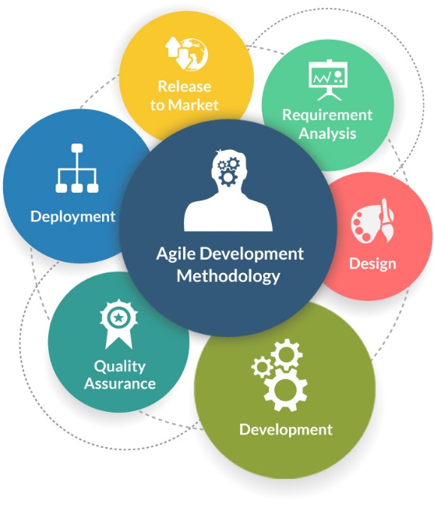

**Figure 5.1**

"Agile process model" alludes to a product advancement approach dependent on iterative turn of events. Coordinated strategies break assignments into littler cycles, or parts don't straightforwardly include long haul arranging. The venture degree and prerequisites are set down toward the start of the improvement procedure. Plans in regards to the quantity of cycles, the span and the extent of every emphasis are obviously characterized ahead of time.

Up close and personal method of correspondence holds more significance than sharing of reports under the light-footed technique. Larger part of groups included are put in open and basic workplaces, once in a while alluded to as "dispatch stages". The workplaces may contain analysts, documentation and help authors, originators that repeat alongside venture supervisors. The strategies for deft programming additionally lay accentuation on practical programming being the underlying advancement measure in blend with favored direct correspondence.

# 6. Requirement Analysis

## 6.1 IntelliJ Idea

IntelliJ IDEA is a coordinated advancement condition (IDE) written in Java for creating PC programming. It is created by JetBrains (some time ago known as IntelliJ), and is accessible as an Apache 2 Licensed people group release, and in an exclusive business version. Both can be utilized for business improvement. Each part of IntelliJ IDEA is planned in view of ergonomics. IntelliJ IDEA is based on a rule that consistently an engineer spends in the stream is a decent moment, and things that break designers out of that stream are awful and ought to be evaded.

The stage offers reusable affiliations major to figure zone applications, enabling originators to base on the strategy for instinct particular to their application. Among the highlights of the stage are:

* Association of User interface (e.g. menus and toolbars)
* Association of User settings
* Storage association (sparing and stacking any kind of information)
* Connection of Window
* structure of Wizard (underpins all around asked for talked)
* Visual Library of IntelliJ Idea
* Integrated Development Tools.

**6.2 WAMP** Server

WAMPs are gatherings of wholeheartedly made endeavours displayed on system that uses a Microsoft Windows working structure. WAMP is an acronym kept from the initials of the working framework Microsoft Windows and therefore the basic parts of the bundle: Apache, MySQL and one in every of PHP, Perl or Python.

## 6.3 J2EE

A Java EE application of a Java Platform, Enterprise Edition application is any deploy- able section of Java EE handiness. this could be a solitary Java EE module or a adding of modules bundled to form an EAR statistics which represents to a Java Enterprise Edition application affiliation descriptor. Java EE applications are normally introduced to be suitable over differnt figuring levels. Knowledge this applications can contain the running with

• EJB modules (bundled in JAR files);  
• Web modules (bundled in WAR files);  
• Connector modules or asset connectors (bundled in RAR files);  
• Session Initiation Protocol (SIP) modules (bundled in SAR files);  
• Application customer modules

Extra JAR files include subordinate classes of particular areas needed by the application; Java, Enterprise Edition or EE Java Platform is Oracle’s meander java usage stage. The platform gives an API and runtime environment for developing and debugging undertaking programming, including web associations and system, and other valuable scale, solid, flexible, multi-layered, and strong structure applications. Standard Edition (Java SE), Java Enterprise Edition augments the Java Platform, giving an application programing interface to acclimation to internal frustration, disagree social mapping, appropriated and multi-level layouts, and web associations. The stage joins a thought work all things considered in light of estimated parts will be on an application server. Programming for Java ENTERPRISE EDITION is largely made within the Java artificial language and utilizations XML for game-plan.

## 6.4 MySQL

The MySQL improvement meander has affected its source to code accessible under the terms of the GNU General Public License, and what’s more under a group of particular confirmations. MySQL was bore witness to and preserved by a lone wage driven firm, the Swedish association MySQL AB, now controlled by Oracle Corporation. Free-programming open source develops that need a full-included database affiliation structure periodically use MySQL. For business use, a pair of paid changes are open, and offer additional regard.  
Applications which utilize MySQL databases include: TYPO3, Joomla, Word Press, phpBB, Drupal and other programming in light of the LAMP programming stack. MySQL is in like way utilized as a pinch of some plainly obvious, liberal scale World Wide Web things, including Wikipedia, Google (in any case not for filters for), Facebook, and Twitter.

# 7. Product Discussion

## 7.1 Technical Architecture

The structure approach has been distinguished as point by point synopsis on what each layer does and the way the knowledge is getting transmitted from edge device to finish clients are advised well as beneath

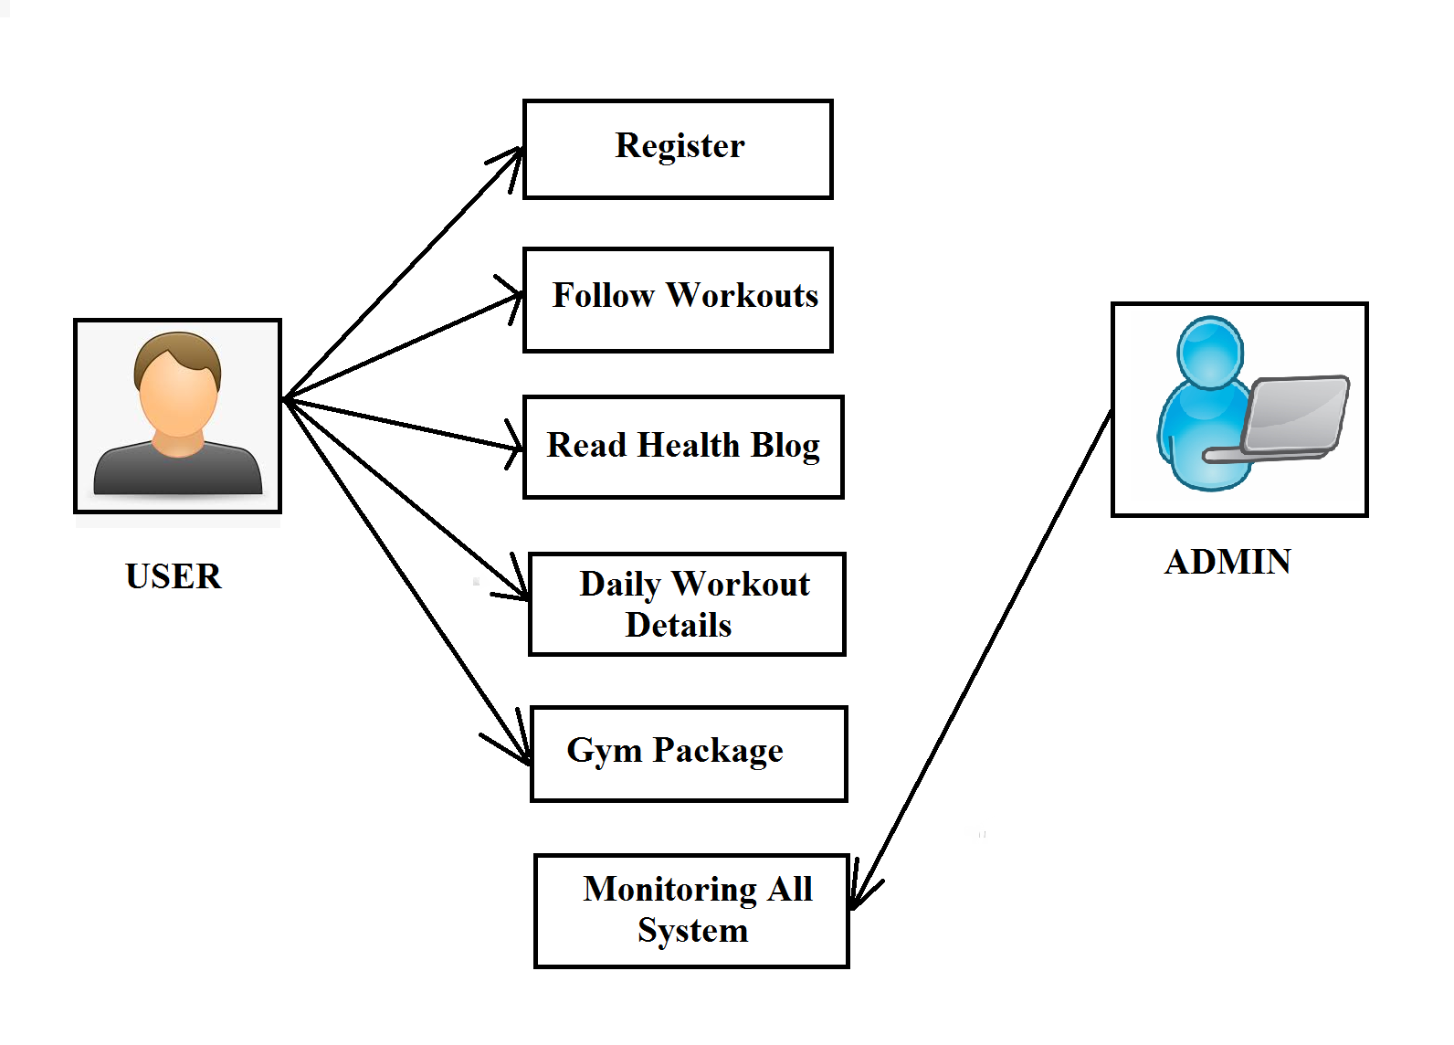

**Figure 7.1**

## 7.2 Module

It is consisting of two models which are listed below:

• Administrative module: The main user is an admin type who has full rights on the system.  
• User module: this is often a standard level of user who are going to be only some number of functionalities of website.

## 7.2.1 Administrative Module:

These module effects storing and retrieving the data details.

* Managing Users
* Maintaining Blog
* Monitoring the Users Daily Status

## 7.2.2 User Module

Based on the permissions of the user’s access to features of the access will be granted.

Below are some of the important features of user module.

* Package access
* Updating Account
* Read Blog related to health
* Login by User-Id and Password
* Email Address Verification
* Authority verification

## 7.3 Features

These application support variants of features some of them are mentioned below

* Using the Unique User Id and Password to login.
* One-time password sent to Email on forget password
* Daily user activities list

## 7.3.1 Features Description

The gym center mechanization framework is straightforward to make the application to use. This makes very useful for the clients and owners as well. it's straightforward in structure and to actualize. The framework prerequisites are pretty much less. Framework assets and therefore the framework will add practically all arrangements. The Gym Automation System robotizes each action and elaborate thoroughly. Along these lines the latency of the framework is a smaller amount and it works very fast.

# 8. Programming Interface of Application

## 8.1 Parameter Consideration in Gym Automation Tool System

Clients are planned to indicate their body necessities alongside their current wellbeing condition additionally past clinical history assuming any. By investigating client gave information, administrator propose them appropriate arrangement of activity and schedule, by following which client can satisfy their wants through our framework. Joining exercise with a solid eating regimen is a progressively viable approach to keep up sound way of life. Consultancy assumes a huge job in boosting one's wellbeing. Client gave information is additionally broke down by administrator so as to anticipate legitimate eating routine and enhancements for the poor exercise and diet plans will be given to client as a proposal reports. Appropriately Following the recommended reports is absolutely duty of clients. An online entryway will be incorporated in framework for direct correspondence between administrator or consultancy and client.

## 8.2 Presentation layer:

The presentation layer is user for the formatting and delivery information to the application layer for further processing or display. This layer has access to the user, Users can view and enter the data thought this layer. The Presentation layer includes HYPER TEXT MARKUP LANGUAGE, CSS, Bootstrap 4 and JavaScript.

## 8.3 Service layer:

The service layer is used for business logic and validation. It accepts the data form the presentation layer do the manipulation and send it to database layer. It also retrieves the data from database layers the serves it to the presentation layer. Java servlet is used for service layer.

## 8.4 Database layer / Database:

Database layer software application that connects directly to a Database. It sends the data from service layer to the database and retrieves the data from the data base and sends it to service layer. Database is in the form of the table and it will store the user required. MySQL database is used to store the data of the user.

# 9. Existing System Constitutes

## 9.1 System Architecture

This framework developed by three sections, including the database, a UI and Server. Auxiliary diagram of the framework as appeared in the figure 8.1. On the initial segment number of clients can enlist themselves in to the gym center mechanization framework. The data can enter on the User Interface, then again it accumulates the aftereffects of the individuals and send to the servers. The administrator assume the job of observing all individuals and the oversee framework. Clients' data which is conveyed to server send to the MySQL database. It store all individuals' data additionally with their everyday exercises. Administrator can bring all the data from database to the User interface.

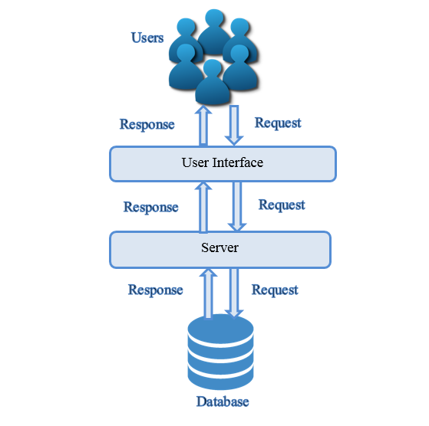

**Figure 9.1**

## 9.2 Data processing

The information get to layer is for the foremost part made out of substance Bean and data get to classes, and there's a coordinated connection between element Bean and tables within the database, arranging the comparing properties through web.xml. Database get to layer gives the bottom of the database get to figure, as an example, through client have to enroll and store the client's subtleties. In execution, UI is that the highest point of the entire framework, which straightforwardly related to the database to accomplish a fundamental tasks.

## 9.3 Design of View Layer

The information get to layer is for the foremost part made out of substance Bean and data get to classes, and there's a coordinated connection between element Bean and tables within the database, arranging the comparing properties through web.xml. Database get to layer gives the bottom of the database get to figure, for instance, through client have to enroll and store the client's subtleties. In execution, UI is that the highest point of the entire framework, which straightforwardly related to the database to accomplish a fundamental tasks

# 10. End to End Architecture

Flowchart is required so that to comprehend the framework well. With the assistance of these diagrams it turns out to be straightforward the sources of info and yields of the framework which is useful in later phases of improvement of the product.

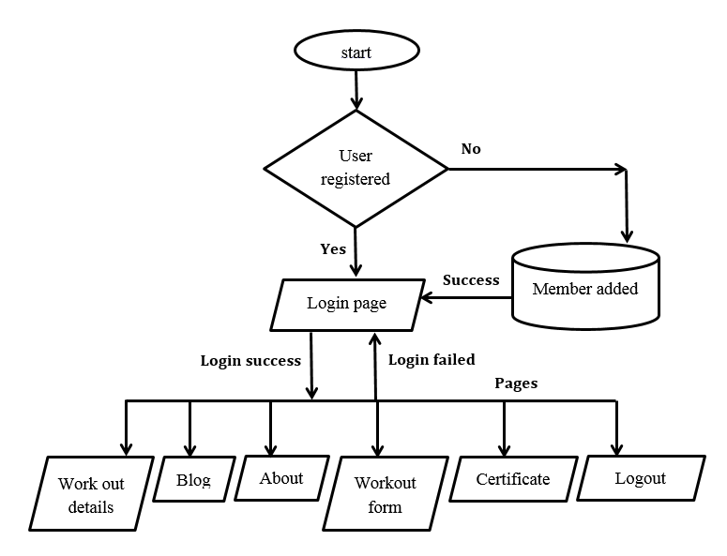

**Figure 10.1**

## 10.1 Explanation

* If the used already exists then user Gym automation system firstly redirects to login form else it redirected to User registration page.
* If user dos not account then user is redirect to the registration page of the user. In registration page of the user, he/she will create account, after that it will redirect to the login page.
* User will enter his/her credentials n login page and user is authenticated , after success authentication user is redirect to workout details page, where he/she can view the type of workout.
* User need to fill the certificate page, where he has answer some questions related ot health.
* There are different page after login like blog page, About page, Workout form page etc.
* After completion of the activity user can be click logout.

# 11. Roadmap Of Proposed Solution

In current gym management system, if we glance the continuing system and compare with the proposed it's far behind. Every add the prevailing is manual and done on the paper.  
There can be a computer used somewhere for the management work but it’s isn't doing exactly it’s is meant which is reducing the manual work. Entering everything manual to the pc by creating a file isn't exactly we are talking in computerization.

Existing system requires lots of manual work, which takes plenty of your time. Activities like updating and synchronizing data are done manually during a non-automated system and that they are a time consuming process.

The system we've got developed could be a full-fledged system, which is that the backbone of gym management so ignoring risk or error isn't an option, then it can make a good appearance of it.

## 11.1 Advantages:

1. The system is profoundly made sure about, in light of the very fact that for login the system it requires the username and password which is diverse for each division hence giving every office an alternate perspective on the client data.
2. The use of this system will alter the trainers as system in having the feature which will explain the gym member about how to perform the activity.
3. User/Gym member needs to fill the workout form daily so that he/she can monitor the plan. Admin user can also monitor the workout of any gym member.
4. Stores information about regular products.
5. It show the information about the membership packages.
6. This application will support by any different operating system because we develop this application in two different operating systems such as MacOS and Windows.

# 12. The Proposed Model Considers These Properties

## 12.1 Internet Oriented

The three different section of the module are used to transfer data between each other. User layer will directly communicate with the server by the use of internet and browser. The layer are two layers of interfaces which for communication between the layers. The model is authorization based i.e. Gym member cannot view admin page as he don’t have access to that page.

## 12.2 Things Oriented

During the process of physical models of the outline, it absolutely was discussed that the project is possible in a technical way where the present model built with software and the respective equipmet.

Following feasibility was considered while proposing the module:

**Technical feasibility:**

It is essential to test whether the existing technical system exists which is feasibly technical or doesn’t & determining technology and skills required to manage the project. You can urge until unless you find out the solution.

**Economic feasibility:**

Feasibility of the financial is checked while examining like performance, activity, information, and the system output. Price of the software is not required additionally it is required for System & general tools of the cliet. The money which is spent on the system is less. Backend Database MySQL is free. It justifies financial viability of the system

# 13. The System Study

## It is reliably essential to take and see the issues of existing system, which can help in finding the necessities for the new structure. System study assists with finding different decisions for better course of action.

## 13.1 The project study basically deals with different operations:

1: Collecting the Information.

2: Understating the existing technology

3: Elaborating the problems with existing system.

4: Analysis the previous research papers

5: Feasibility concentrate for additional enhancements

## 13.2 Following are the steps taken during the initial study:

From the outset, we accumulated all the data, which they expected to store. Around then we pondered the working of this structure which is finished genuinely. We saw the limitation of that system which prodded them to claim new structure. With the assistance of those records we got principal considerations viewing the structure even as data yield of the made system.

The most critical thing is to contemplate over system through and through. Here we are thinking about both existing system and proposed structure so central focuses and blocks of both the structures will be grasped. the principal undertaking was perceiving how system is modernized. Some assessment and projections was done regarding changes to be made to the current structure. The new advanced system for Gym Management is basic without complexities.

## 13.3 Existing System

An Existing system suggests the structure that is being followed till now. The activity place is working truly. this system is repetitive and moreover it's over the top, because it incorporates a decent arrangement of work area work. To truly consider the system was inconvenient task. Regardless, by and by a-days computerization made easy to figure.  
The following are the explanations why the present system should be computerized:

* To increment productivity with decreased expense.
* To minimize the burden of constant paperwork.
* It will save the recording time of the workout.
* Automatically generate the workout result.

## 13.4 Proposed System

The activity place organization structure is easy to get a handle on application. This automated structure makes all helpfulness less difficult for the 2 landlord and customers. it's particularly essential in plan and to execute. The required structure is incredibly low. System resources and along these lines the structure will include for all intents and purposes all arrangements.

It has the accompanying targets:

**Enhancement:**  
 The main intent is to upgrade and update the current structure by extending its capability and reasonability. the product working techniques are improved by replacing this manual structure with the Personal Computer based system.

**Automation:**  
 It mechanizes each development of the manual structure and extends its way. Thusly the dormant time of the structure is a littler sum and quickly works.

**Accuracy:** The outfits the uses a snappy response with accurate information about the customers and afterward forward. Any nuances or structure in an exact manner, as and when required.

**User-Friendly**:

The product System consolidates a simple to utilize interface. In this manner the customers will feel particularly easy to require an endeavor at it. the product outfits precision close by an exciting interface. It turns out current manual system dynamically shrewd, quick, and easy to know.

**Availability**:

With definite no late, inside the information availability, whatever required, is gotten quickly and with no issue.

**Maintenance Cost**: Lesser the expensive cost.

# 14. UML Diagrams

## 14.1 Use Case Diagram

A Unified Modeling Language could be a sensibly social design elaborated by and made of a assessment use case. It motivates to show a graphical chart of the value given by a system with respect to on-screen characters, their result, and any provide conditions between usage cases. The rule elaboration in the behind case case plot is to exhibit the character on screen when structure limits plays a role. Occupations of the performing craftsmen within the existing system are regularly depicted.

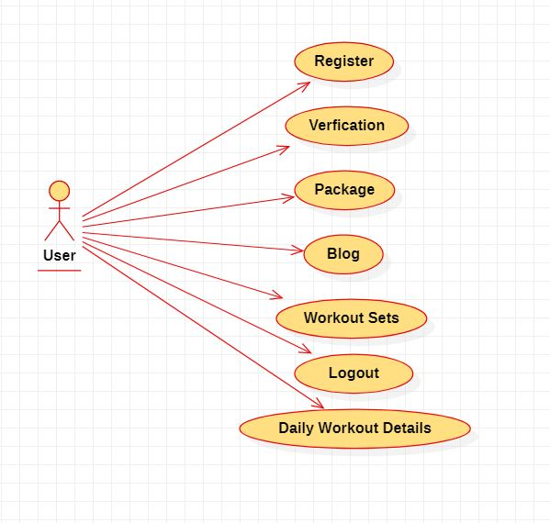

**Figure 14.1**

## 14.2 Sequence Diagram

A grouping diagram in (UML) could be a sort of collaboration outline that shows how structures work with each other and it's a form of a Message Sequence Chart. Game plan plots are from time to time called event diagrams, event circumstances, and timing outlines.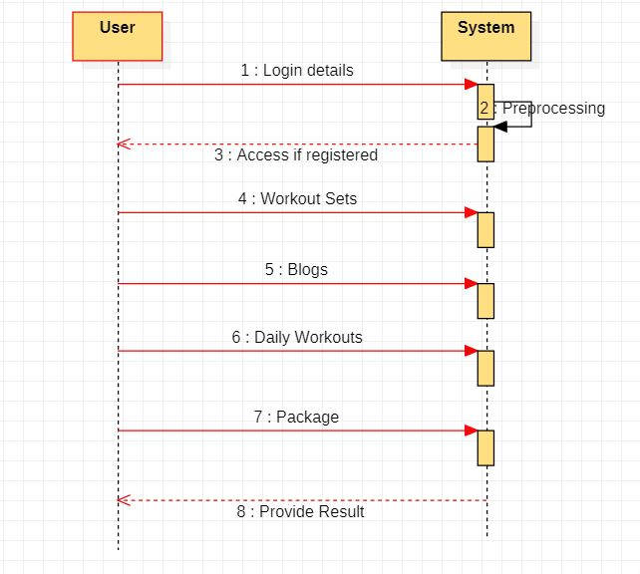

**Figure 14.2**

## 14.3 Class Diagram

This area portrays information demonstrating utilized for investigation of information protests inside the framework and furthermore the ID of the connections among these information objects.The subsequent figure shows class diagram for the system.

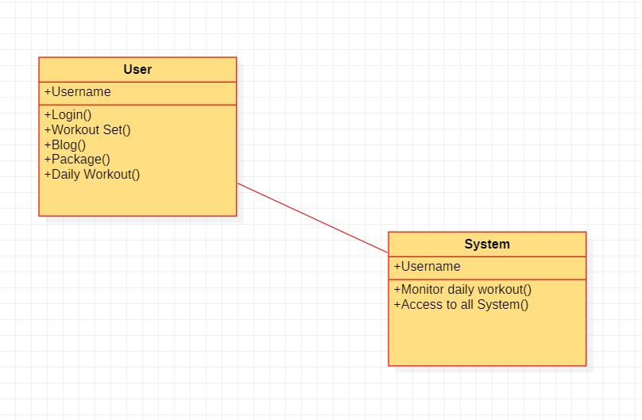

**Figure 14.3**

## 14.4 Activity Diagram

It represents flowchart to represent the result of one to another activity. Each activity describes system operation. The flow of control is laid between one operation to the other operation. It showed within the following figure.

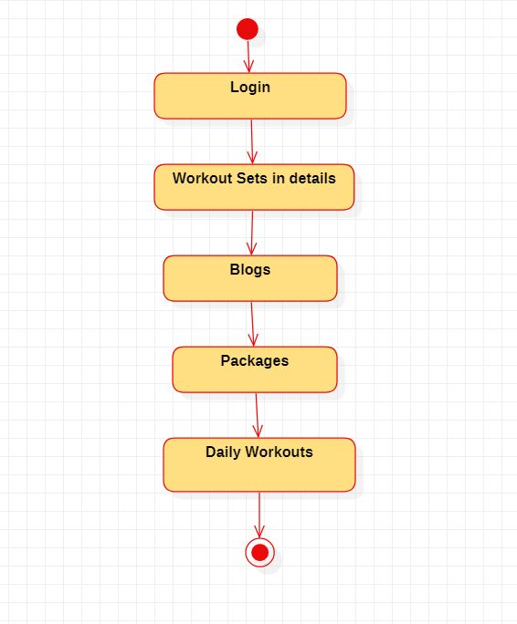

**Figure 14.4**

# 15. Software Requirements

## 15.1 User Interface:

* Hyper Text Markup Language has been used for layout development for the user.
* It is used for validation creation and scripting function from the client side.
* Cascading Style Sheets and Bootstrap 4 have been used for website design for the system.

## 15.2 Application:

* Client on Internet system: Browser, OS (MacOS or Windows)
* Web Server (local server): Apache Tomcat
* Backend: MySQL (WAMP SERVER)
* Markup Language: HYPER TEXT MARKUP LANGUAGE, CSS with JAVA Server pages (JSP).
* Scripting Language: JavaScript, JQuery.
* Server Language: JAVA (Servlet).

## 15.3 Development and Build process:

* The life cycle and the development are Agile, and approach is incremental.
* The whole product is developed in span of three months considering all the wants

## 15.4 Testing:

System testing is meant to expose the unexpected loop poles within the previous test. During this, the execution of the program is done during testing time and explicitly intent of finding flaws. This includes compelling system failures and validation. Its user executes it within the system's operating environment. For these utility test cases are developed.  
Incremental testing has many benefits. it's easy to decrease errors. The partial aggression of the modules are often important subsystems that may be autonomous with these tests. Reducing the necessity for stubs and drivers.

## 15.4.1 White Box Testing

 This approach is a detailed examination of the logical components by the software may be tested by species situations or trapping exercise cases. It checks all the possible components logically once. Errors are identified and sorted out with the help of typographical method, logical expression which executes only one time. Independent components are tested by the box testing module for his or her true and false logical decisions and are used and the internal system is employed once to make sure their validity.

## 15.4.2 Black Box Testing

It allows the applied scientist to line up a bunch of technical inputs and completely utilize all required functional programming. The recording machine tests in and out and external data as well. It verifies input file which is valid or not and output completely our own wish.

## 15.4.3 Alpha Testing

It is also called as acceptance testing. This system is compactable for only one customer. It works only if customer and the developer of the system agree for implementation of the specific requirements of the concerned system.

## 15.4.4 Beta Testing

It is used only when it identifies the product so where the beta testing required. During this testing, the potential customers uses the distributed system who comply with use it. Any problem user can able to let the developers to know. This provides the merchandise for real use and identifies errors that system developers don’t.

## 15.4.5 Unit Testing

Each module is considered independent. It focuses on every bit of software implemented in ASCII text file. this is often a white box test.

## 15.4.6 Integration Testing

The Integration testing Program aims to create architecture, while building tests that uncover deficiencies related to interfacing modules. The modules will be integrated using the highest down approach.

## 15.4.7 Validation Testing

It is used to make sure functional and the performance of the individual are verified and met the conditions.

## 15.4.8 System testing

It runs program to test for legitimate modify to be done with the goal of discovering mistakes. A system is tried for online reaction, volume of exchanges, and recuperation from disappointment. It is finished to so that system fulfills all the client necessities.

## 15.5 Implementation and Software Specification testing

**Detail Design of implementation**

This development system lifecycle phase of the system is improving hardware and software specifications, fitting programming plans, training customers and implementing the procedures in extensive way, providing the idea for assessing or modifying design and operating specifications.  
  
**Technical Design**

This functionality depends on the created inside the configuration of the newly developed system, which includes documentation and determination of point by point.

**Testing Specification and Planning**

This functionality should be attentive to definite testing subtleties for singular modules, work streams, subsystems and the complete system.

**Programming and Testing**

It includes testing the modules which includes development, writing, testing it.  
**User training**

This activity incorporates composing user strategy manuals, getting ready user training materials, directing training projects and testing methodology.  
**Acceptance test**

Final policy review to point out the system and to procure the approval of the user before the system is operational.

**Installation Phase**

At this stage the new automated system is introduced, transformation to new system is completely actualized and furthermore the capability of the new system is investigated.

**System Installation**

The triggers the initializing of the system with the operation involved in training the personal user.

**Review Phase**

This step assesses the success and failures inside the system developed undertaking and measures the output result of the new modernized transistor as far as the advantages and investment funds secured inside the start of the protection.

**Development Recap**

The project is reviewed as soon as because it is completed to seek out successes and its related problems in upcoming/future work.

**Post implementation review**

The system gets executed when the review is been led for a couple of time to guage perfect system execution against good desires and advantage of money collecting upgrades. It likewise distinguishes the executive’s tasks to upgrade for the betterment of the system.

**Steps in Software Testing**

The Steps involved for unit testing are as follows:

A. Planning for test cases.

B. create all possible test cases with all the related valid checks.

C. Complete code check of each module.

D. Manual is done for the standard test.

E. modification made for the errors to detect during testing.

F. document test result scripts.

**The Unit Testing is done with the following terms of testing:**

1. Entire module / functionality of the forms
2. Validating the input provided by the user
3. Checking the standard of the coding to be performed during coding process.
4. Module is been tested with all possible test data
5. Examination of all kinds of calculations etc.
6. Standard comments on the source files.

After all the modules completing the unit testing, the complete system is connected to all or any of the module dependencies. During System integration, however, we need all the system to be integrated and tested in each step. This would helpful in reducing the errors during system testing.

**The Steps involved in the system testing are:**

A. Planning for test cases.

B. create all possible test cases with all approved checks.

C. Complete code check of each module.

D. The standard test will be done with manual testing

E. During Testing, the errors are detected and modified

F. Result for the test are documented

**The system testing has done which includes the following terms:**

1. Functionality of the whole system.

2. User layer of the system.

3. Testing based modules combine with all possible test data scripts.

4. Verification and validation test.

5. Testing the reports with all its functions.

After completing the system test, the subsequent step is that the acceptance test. Clients did this on their end and approved the system confidently. Thus, we have reached the ultimate stage of protective delivery

# 16. System Analysis

## 16.1 Introduction To system Analysis

System Analysis is data that gathers and clarifies about the facts, analyze issues and suggests upgrades inside the system. this can be a contention of the activity solving that needs escalated correspondence between framework users and framework designers. Framework investigation or study is a pivotal advance of any framework improvement process. Contemplated and dissected the framework inside the littlest detail. The framework investigator assumes the job of examiners and lives further into crafted by the current framework, Analyzing and blending different angles and deciding the privilege or least agreeable arrangement or program of activity. a top to bottom investigation of the technique ought to be done through different strategies like meetings and surveys. the data gathered through these sources ought to be analyzed to increase an end. the top is to get a handle on how the framework functions. this method is named this framework. the current framework has been concentrated intently and issue zones are distinguished.

The designer now works as an issue solver and tries to resolve the difficulties the corporate is facing. Solutions are given as proposals. The proposition is systematically weighted with the current framework and furthermore the best one is picked. A user's proposal endorsement is submitted to the user. The proposal is assessed, and suitable changes made at the user's solicitation. This closure following the user is happy with the offer. preliminary study is that the way collecting the facts together by utilizing data for additional studies on the framework. The preliminary study might be a critical thinking action that needs concentrated correspondence between framework users and framework designers. It does different feasibility studies. In these studies, a thorough number of framework exercises is acquired, from which to go to a choice on the methodologies to be followed for successful framework study and investigation.

## 16.2 Feasibility Study

The feasibility study is going to be done to determine if the work of the defense company is well worth the effort, time and energy it'll cost. The feasibility study allows the developer to forecast the long run and therefore the way forward for the applying. A feasibility study of the system proposal is in terms of its working ability, its impact on the organization, their ability to fulfill their customer needs, and therefore the efficient use of resources. Therefore, it always goes through a feasibility study when a replacement application is proposed. This report plots the possibility of the assurance being planned and provides different areas that are to be considered.

# 17. Future Scope and Limitation

The product is flexible in a way to acknowledge alterations and changes can be made utmost ease. It is very easy to understand for the merchandise and get assured that any progression can be made easily for future with no exemptions.

Since the goals have got better future, the framework is easily altered such an ease manner, because the framework has been modularized. What's to return extension would be possible in a very brief way so on improve the productively of the framework.

Below is the list shown which must be consider for the long run:

* We can have multi-tenant support for this in future.
* Online payment facility may be added.
* We can notify through message to the user every week before expiring gym membership
* User/individual can make an entry to the gym with the help of card with barcode generation.
* We can add videos of the workouts.

# 18. Conclusion

The goal of this task was to manufacture a program for maintaining the subtleties of the considerable number of people representatives and stock. The framework created can meet all the elemental necessities. The administration of the records the 2 individuals and representatives are going to be additionally profited by the proposed framework because it will mechanize the whole technique which can decrease the remaining task at hand. the safety of the framework is likewise one amongst the prime concern.

**Goal Achived:**

The application is in a position to supply the interface to the owner likewise as gym member in order that he/she can replicate desired data.

# 19.User Manual

|  |  |  |
| --- | --- | --- |
| Serial no. | Particulars | Page no. |
|  | How to Register and Log in account | 25 |
|  | How to check Workout | 25 |
|  | How to Get Medical Certificate | 26 |
|  | How to Upload Workout | 27 |
|  | How to check Packages | 27 |
|  | How to see Blogs | 28 |
|  | How to Log out account | 29 |

## 19.1 How to Register and Log in the account

Every user must use their own id and password to log in page. But, before login you must have to register with the system. For register, Go to Sign up page, fill your details, Create Username and Password and Click on register. After registering you will receive a mail for verification. Click on that link to verify your id and after that go to sign in page and you can log in to your account.

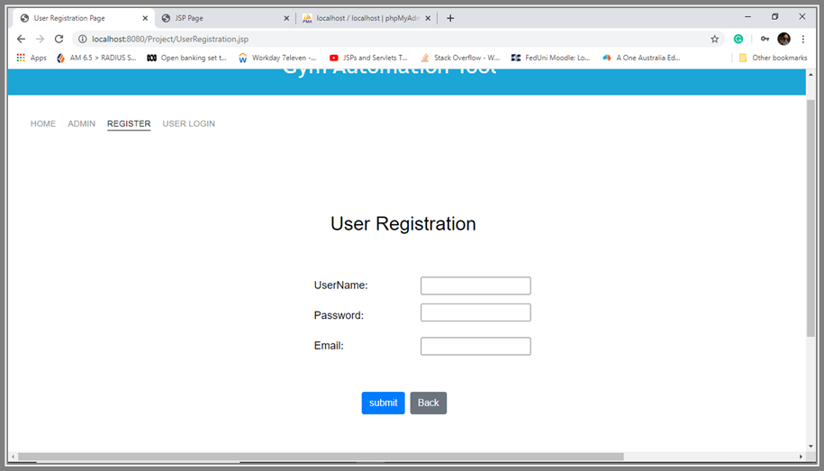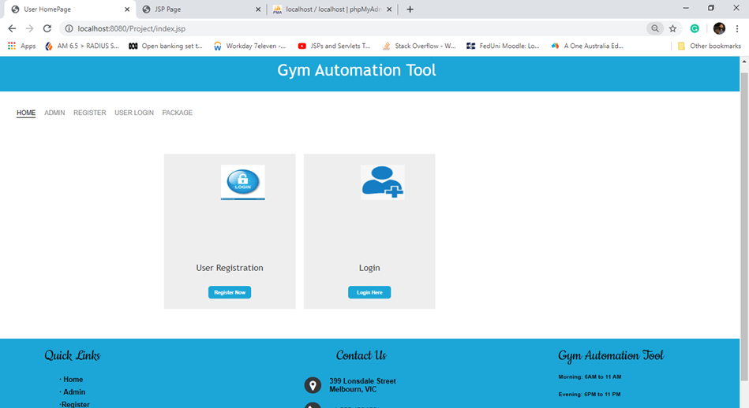

# 19.2 How to check Workout on site

We are providing various workout on site to do in the page. Users can choose anyone according to their requirements. To select any workout, click on one workout what you want to do, you will see the detail or description of that exercise with image for effectiveness.

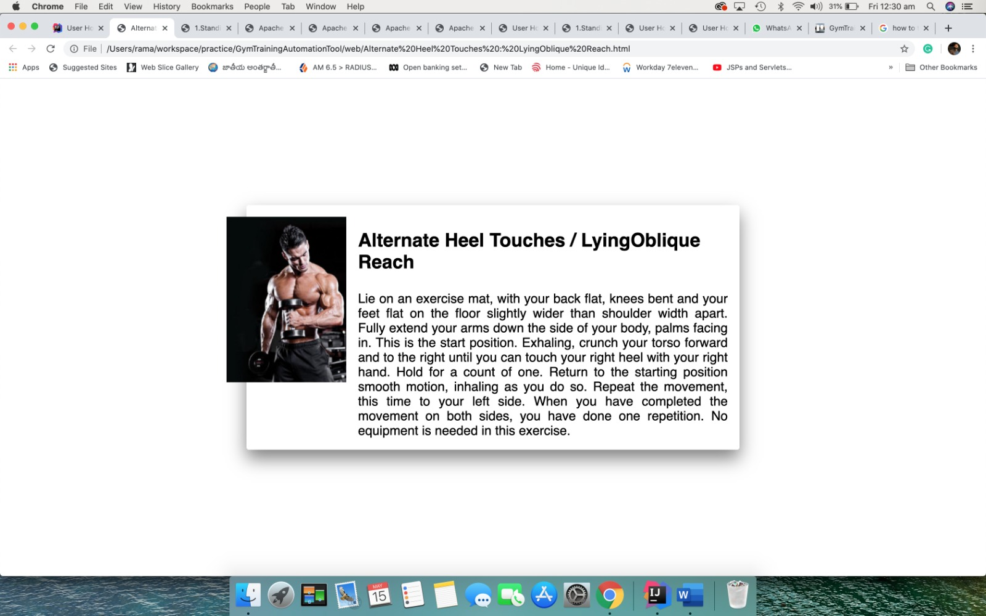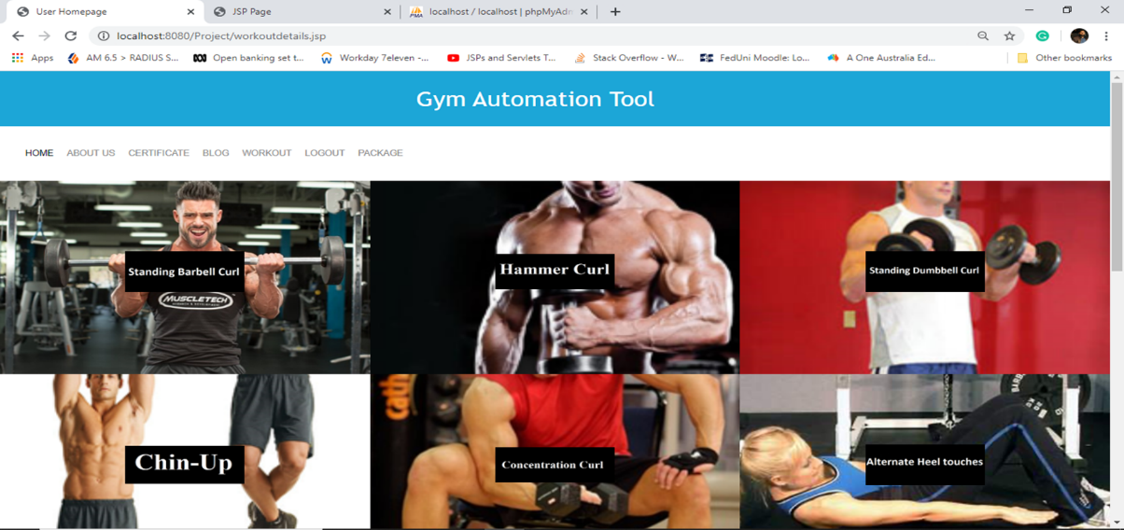

# 19.3 How to Get Medical Certificate

We are providing medical certificate to our registered member or user of the gym. But, for getting that certificate users must have to answer some questions. Click on Certificate command on the site into your account. You will directly go to Questionnaire page where user have to provide some details and answer to some question. According to answers, system will provide Medical Certificate to user.

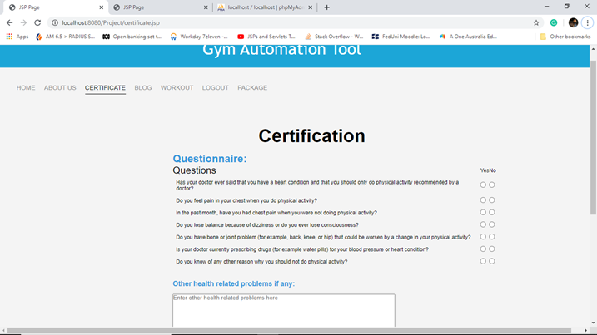

# 19.4 How to Upload Everyday Workout

Every user must have to upload their workout detail into their account for checking progress of their goal. Click on workout command on site into own account and you will see the screen of workout where you have to some enter some details like: Date, Time, Warm-Up Minutes, Hardcore Minutes and some other details.

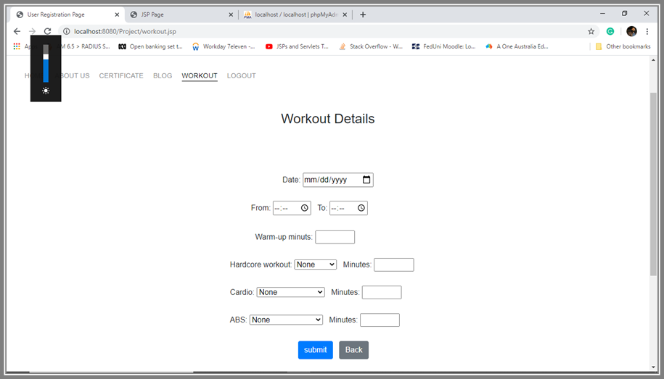

## 19.5 How to Select Exercise Package

Admin is offering different exercise package for the users. Some of the packages are free or some packages need to pay. User can choose according to requirement. For checking or selecting package, click on packages command on site, you will directly go to package pages where you can various package with full details and select any with own requirements.

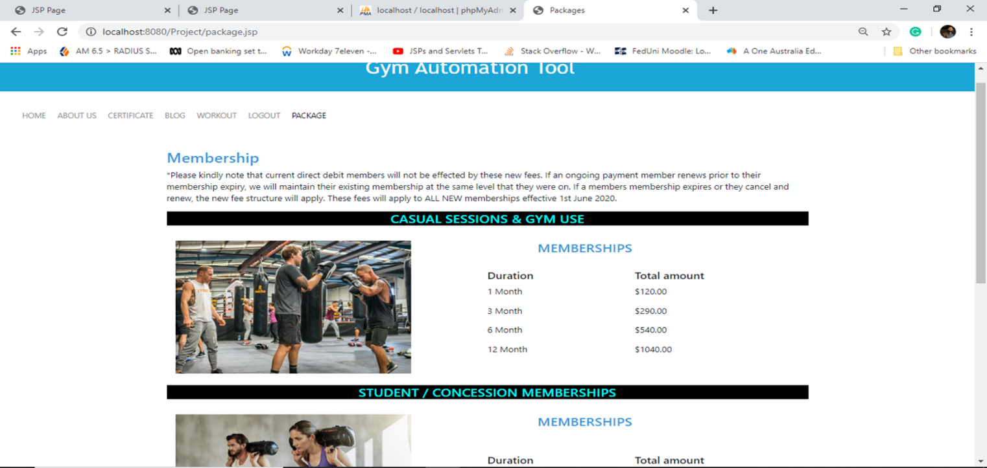

## 19.6 How to check Blogs on site

Blogs helps the user and admin to keep updated with the exercise and keep motivated to do exercise for staying healthy. Blogs are proving extra knowledge how to remain fitness in the body and stay fit. To check different blog on site, click on Blog option on site and you will see the lots of blogs on site which motivates you to do exercise and help you to do exercise properly and provides additional information to remain fit.

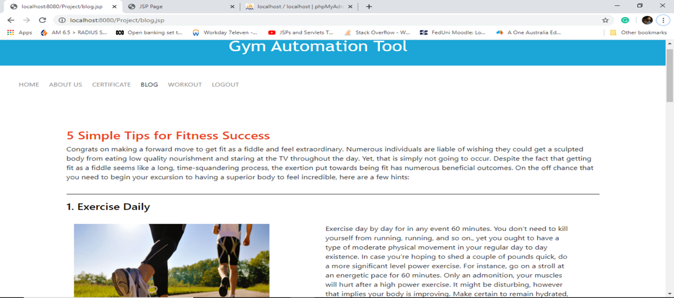

## 19.7 How to Log out from account

Log out is necessary from the account. Everyone has their own privacy and secrets. If user doesn’t log out their account, this can be hacked and use by another user. To log out from account, click on Log out command from on site, you will go to home page of the site.

# 20. List of exercise

## 20.1 Push-Up

steps to do:

* Begin down on the ground putting your hands on the floor marginally more extensive than shoulder-width separated. Your body should frame a straight line from your lower legs to your shoulders. Press your abs as close as could be expected under the circumstances and keep them contracted for the whole exercise.
* Lower your body until your chest about contacts the floor, ensuring that you fold your elbows near the sides of your middle. Delay, at that point propel yourself back to the beginning position.

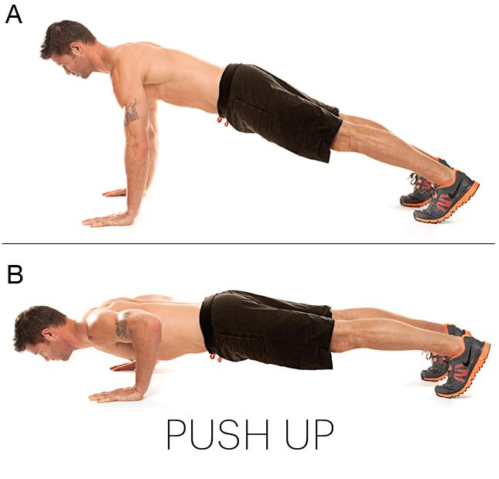

## 20.2 Squats

steps to do

* First of all, make the feet shoulder-width apart and stand as long as much you can. Keep your in front of you at chest height to keep remain the balance.
* Drop your hips and sit on the floor until it contacts with the floor. Take some time, lift your body upwards to the starting position, squeezing the glutes at top of the movement. Take some rest, after that do the same position at least for 10-20 times.

## 20.3 Single Leg Balance

you must your own shoes and wear that one and find the flat area to do the exercise. Lift upward your one leg up to the hip so your thigh is parallel to the ground and the other leg should be straight down. Raise your arms if you feel unwell to keep balance of the body. Keep going with this process, close your eyes and stay balanced. Your body must be remaining straight and hips and shoulder need to be balanced. In some case, if you lose your balance, don’t be panic and start over and over. You will get know when you can remain your balance for log period.

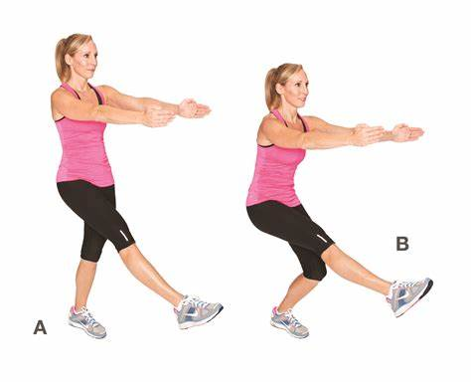

## 20.4 Skipping

– steps to do:

* Hold each handle of the rope and placing the rope behind you. Holding handle is more important in this exercise.
* Swing the rope up and over your head. As it touches your feet, you have to jump little bit and make the rope pass under your feet. Keep going with this process and do the maximum you can.

## 20.5 Cycling

An upstanding bicycle all the more intently reproduces riding a bike, while a supine bicycle lets you recline and pedal with your legs before you. In the event that you decide to do span preparing, you will alter the obstruction so now and again you need to buckle down. Follow these with rest periods by diminishing the opposition. Start moderate and speed up and obstruction following a couple of moments. Toward the finish of the exercise, slow down and abatement protection from help cut your pulse down. You can pick to what extent you need to work out, screen your pulse, and set a particular obstruction level. You can pick programs intended to consume fat, form certain muscles or increment continuance.

## 20.6 Standing Barbell Curl

Snatch the free weight with an underhand hold, with your hands situated about as wide as your hips. To stress the inward bit of the bicep, take a more extensive hold; to focus on the external piece of the muscle, unite your hands. Begin holding the bar at hip tallness, at that point crush your centre and agreement your biceps to twist the bar up to bear stature. Crush your biceps at the highest point of the development, at that point gradually bring down the weight back to the beginning position, controlling the weight through the flighty development. Make a point to keep your feet positively planted all through the activity, and don't utilize your hips to lift the weight.



## 20.7 Hammer Curl

Snatch a couple of free weights and let them hang at a careful distance close to your sides with your palms confronting your thighs. Without moving your upper arms, twist your elbows and twist the hand weights as near your shoulders as you can. Interruption, at that point gradually bring down the weight back to the beginning position. Each time you come back to the beginning position, totally fix your arms.



## 20.8 Standing Dumbbell Curl

First of all, stand on flat area of the floor and after that, snatch a pair of dumbbells and lift them upwards up to the arm’s length next to your sides. Turn your arms so your palms face forward. Don’t move your upper arms, bend your elbows and curl the dumbbells as close to your shoulders as you can. Take some time, then decreasingly lower the weight back to the starting position. Whenever you come the starting position, fully straighten your arms and take some rest.

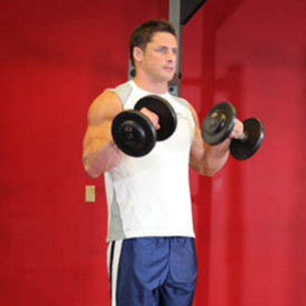

## 20.8 Chin-up

Snatch a chinup bar utilizing a shoulder-width underhand grasp and hang at a careful distance. Crush your shoulder bones down and back, twist your elbows, and pull the highest point of your chest to the bar. Respite, and gradually bring down your

Body back to the beginning position.

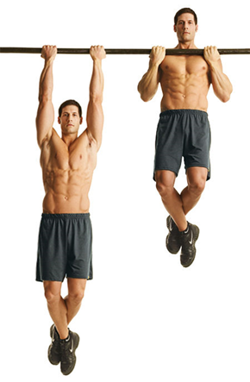

## 20.9 Concentration Curl

User need a dumbbell and bench or desk to strat this exercise. After sitting on the bench, widthen your leg as much as you can. Hold the dumbbell in one hand and with same leg side, down your arm below the knee. So, that weight can hang down between your legs. Keep uplifting the the weight, focus on sequeezing the bicep, take some time at top and then go back to the starting position. Keep going with this exercise and do this the maximum you can.

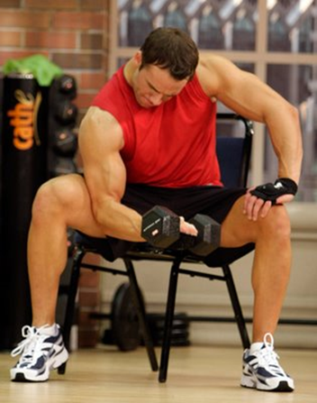

# 21. Screens

Home Page:

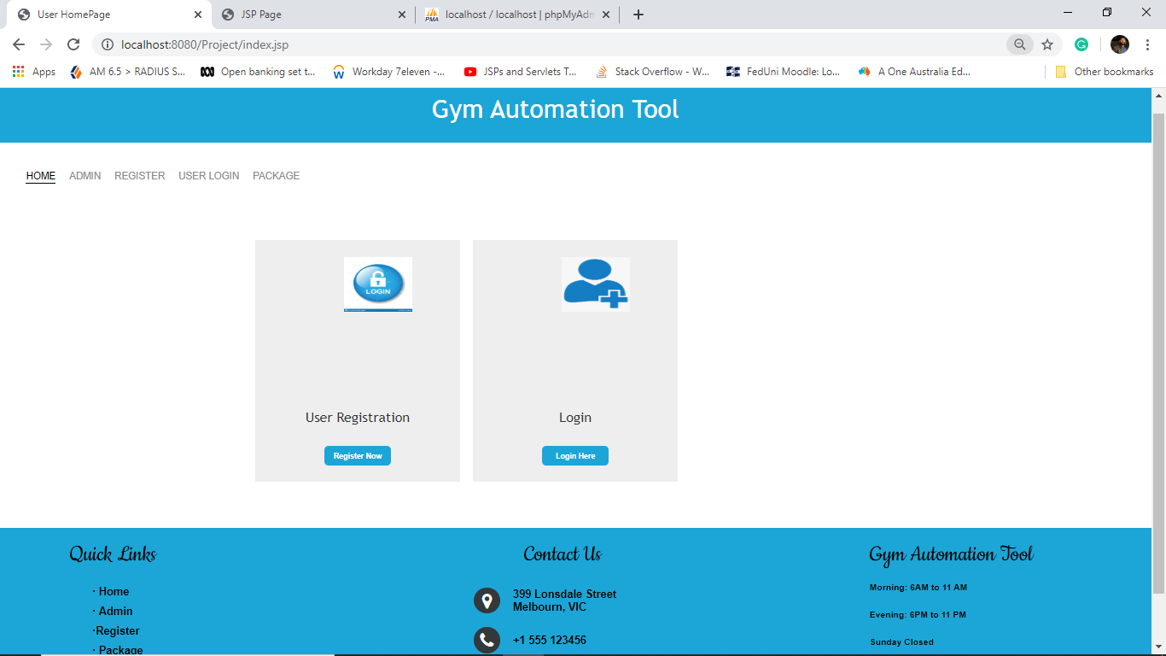

Registration page:

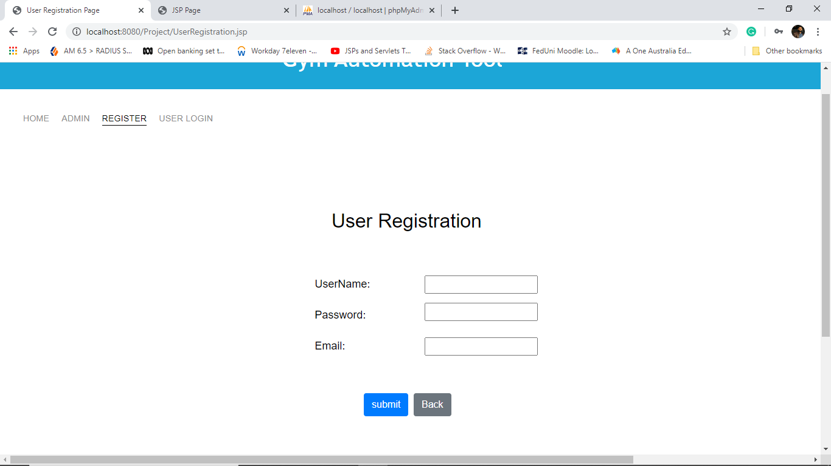

Login Page

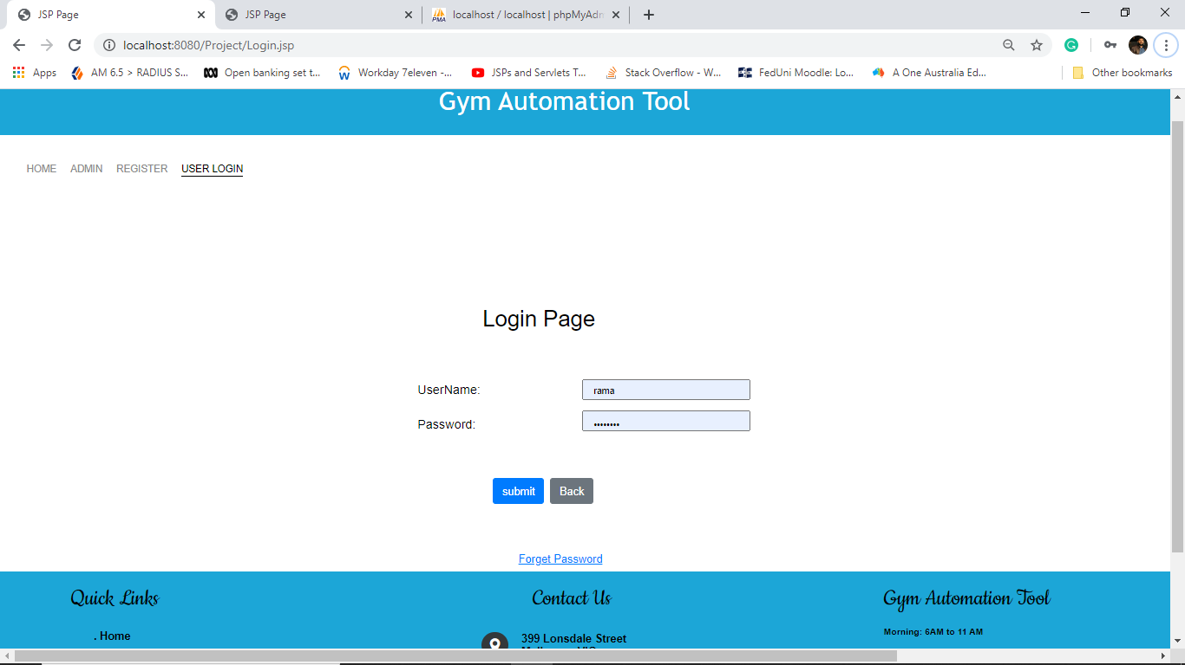

Forgot Password:

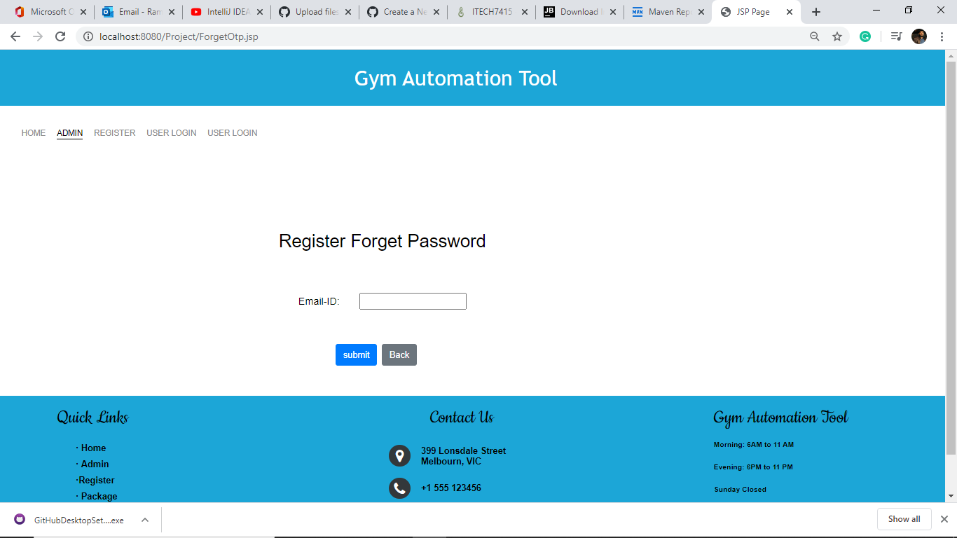

One-time password send to Email

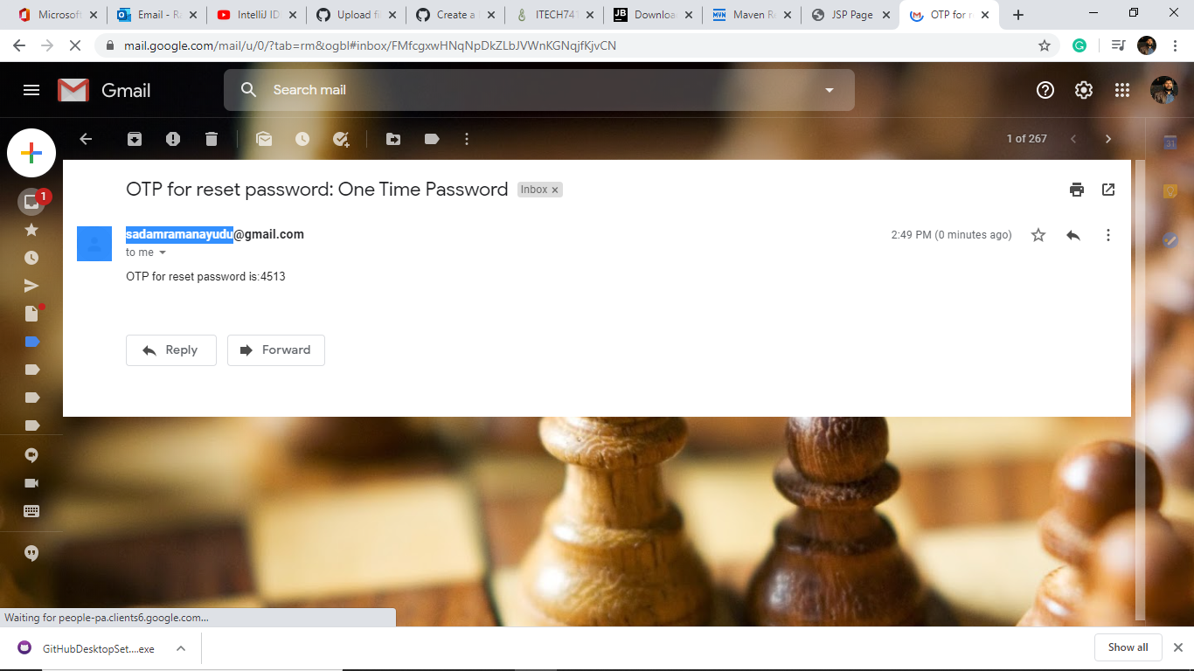

Reset Password Page

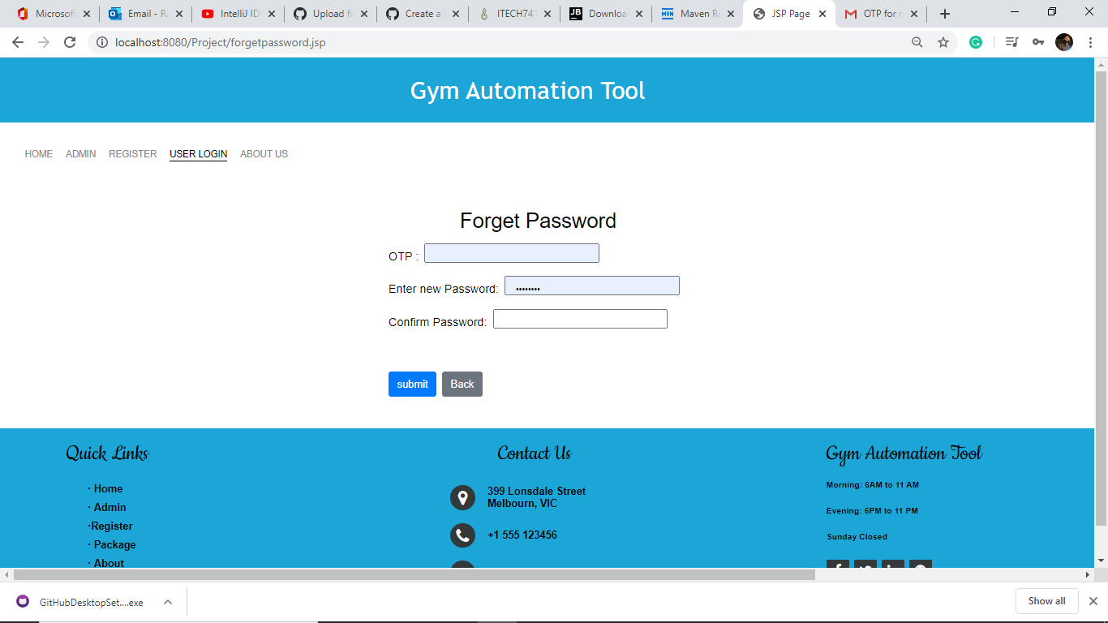

Work outs page:

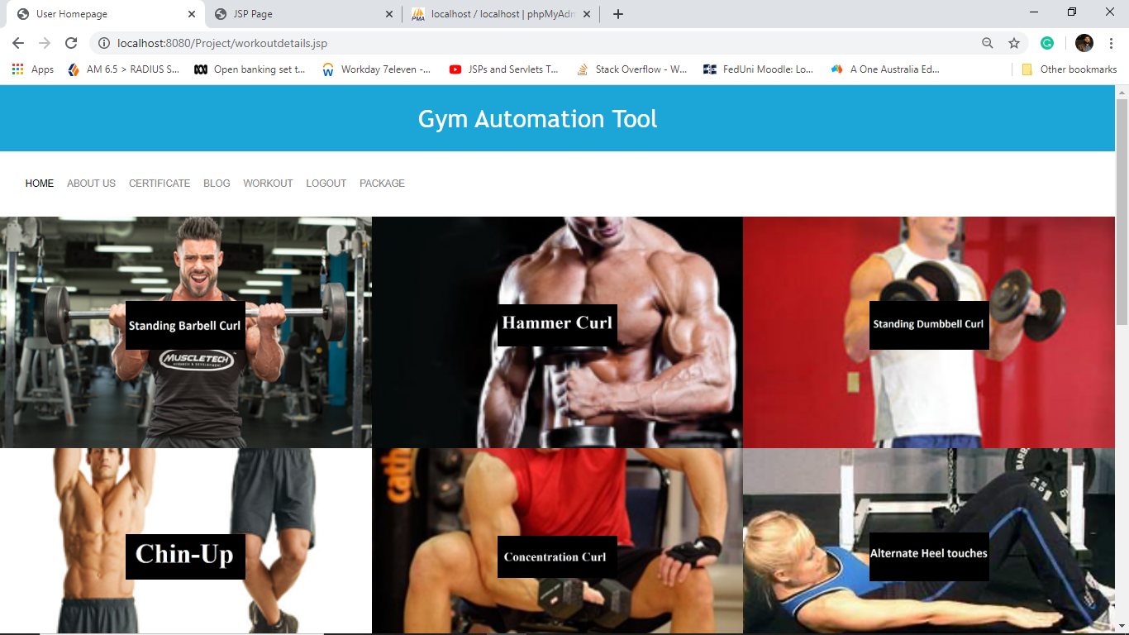

Medical page:

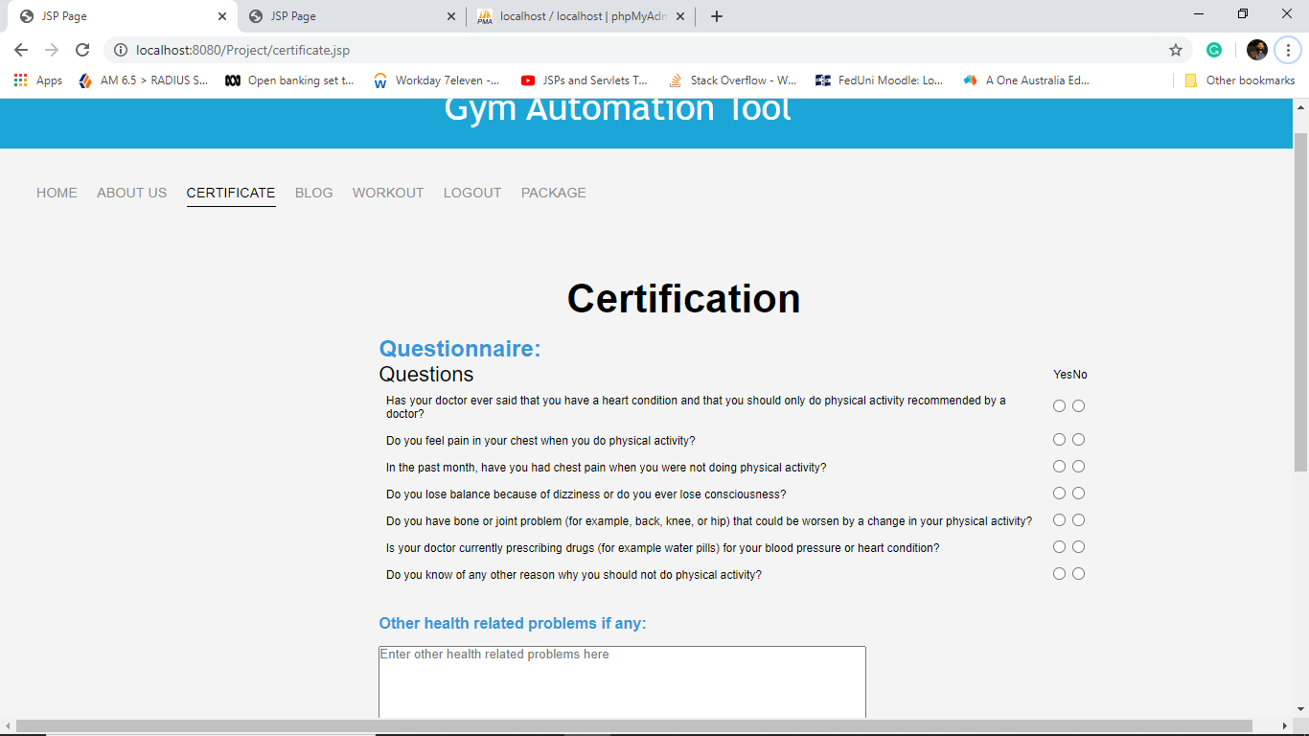

Blogs

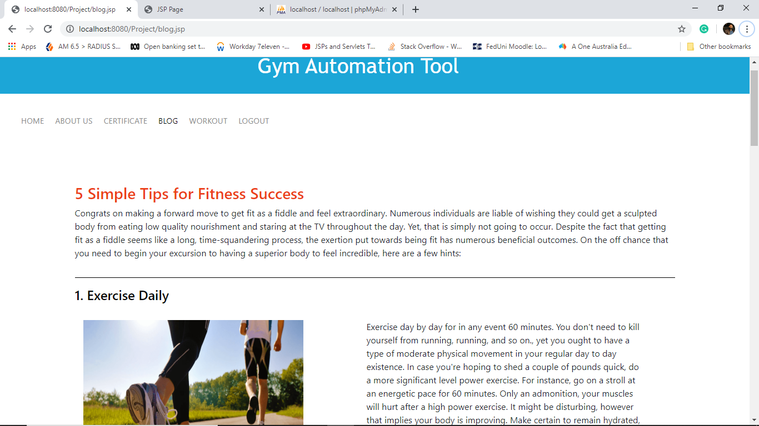

Workout page:

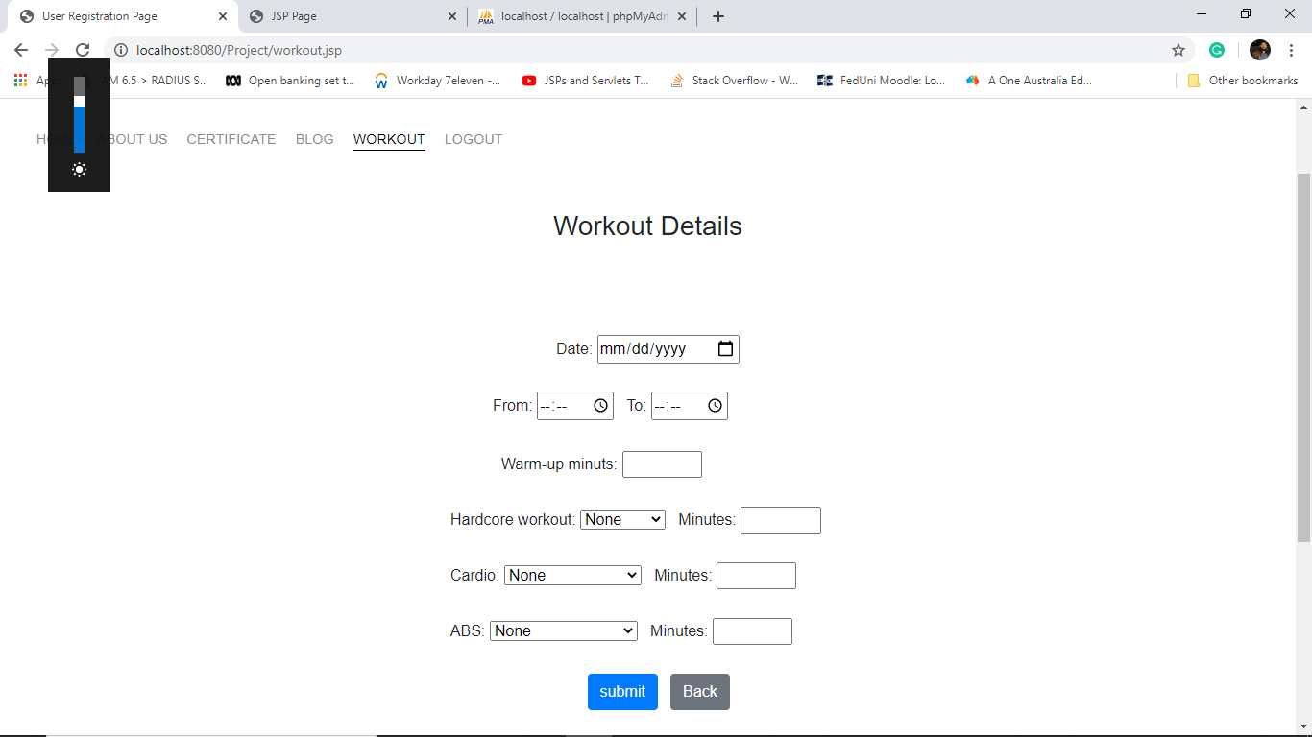

Packages:

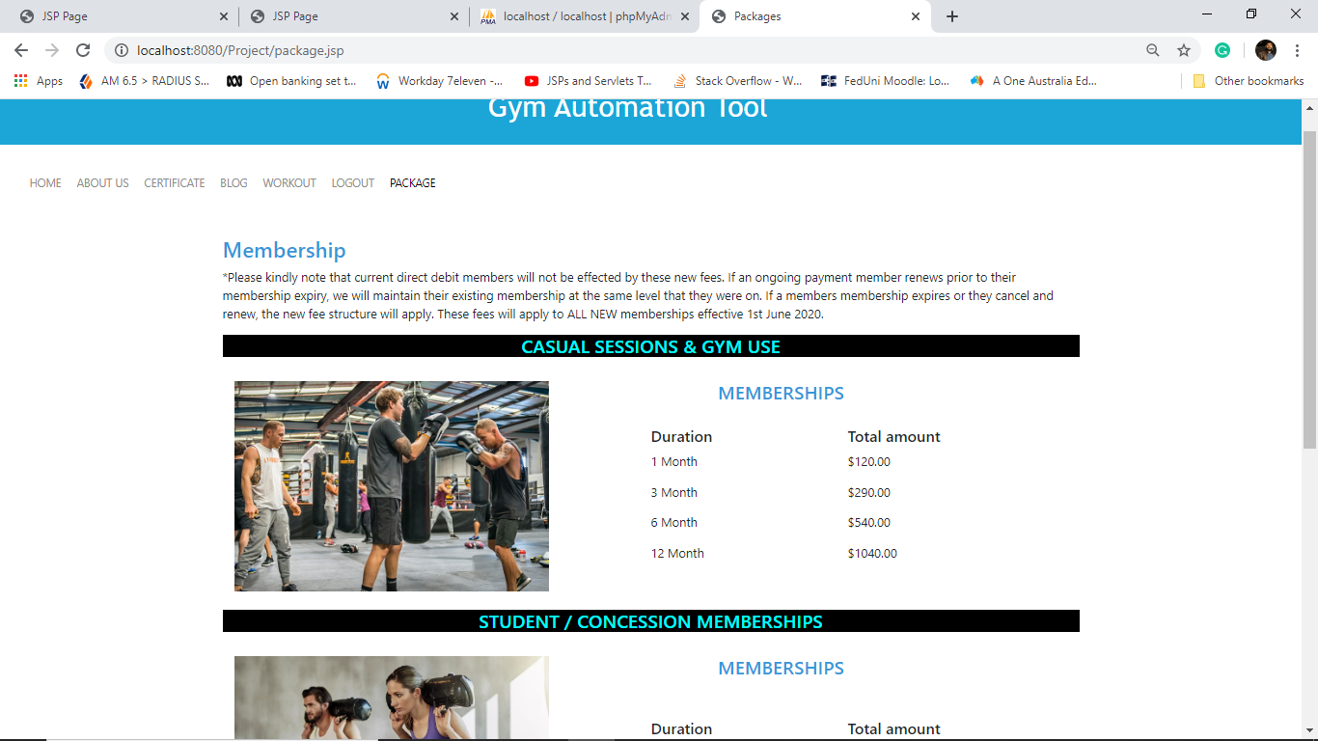

Admin Page:

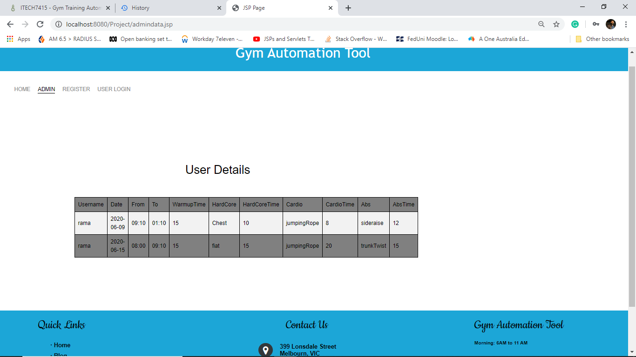

# References

1. Van Hilvoorde, I. Fitness: The Early (Dutch) Roots of a Modern Industry. Int. J. Hist. Sport 2008, 25, 1306–1325. [CrossRef]
2. International Health, Racquet & Sportsclub Association. The IHRSA Global Report; IHRSA: Boston, MA, USA, 2017.
3. Europe Active. European Health & Fitness Market: Report Deloitte; Europe Active: Brussels, Belgium, 2018.
4. Parviainen, J. The standardization process of movement in the fitness industry: The experience design of Les Mills choreographies. Eur. J. Cult. Stud. 2011, 14, 526–541. [CrossRef]
5. Andreasson, J.; Johansson, T. The Fitness Revolution. Historical Transformations in the Global Gym and Fitness Culture. Sport Sci. Rev. 2014, 23, 91–111. [CrossRef]
6. International Health, Racquet & Sportsclub Association. The IHRSA Global Report; IHRSA: Boston, MA, USA, 2018.
7. Breesch, D.; Vos, S.; Scheerder, J. The financial viability of the fitness industry in Belgium. Sport, Bus. Manag. Int. J. 2015, 5, 365–385. [CrossRef]
8. Kratzman, V.A.; Stamford, F. US Fitness Industry: Market Overview and Entry Strategies; Tekes National Technology Agency: Helsinki, Finland, 2002.
9. Sekendiz, B.; Gray, S.E.; Norton, K.; Keyzer, P.; Dietrich, J.; Eickhoff-Shemek, J.M.; Finch, C. Safety Alert for Treadmills in Health & Fitness Facilities in Australia: Results from a Pilot Study of an Observational Audit Tool. J. Fit. Res. 2016, 5, 24–28.